LOCAL JOB BOARD FOR SHOPS & SMALL BUSINESSES
@CREATIVITY THINK (9483175986/7019689991)

ABSTRACT:
Local Job Board for Shops & Small Businesses is a web-based platform designed to facilitate job postings, applications, and basic analytics for small businesses, local shops, tuition centers, and offices. The platform allows job seekers to browse openings, apply with short profiles, track application status, and rate employers. Administrators can verify employer accounts, moderate job posts, handle spam or fake listings, and generate analytics reports for informed decision-making. Developed with Django and Django REST Framework for backend services, and React with Redux and axios for frontend operations, the system provides a streamlined and efficient approach to local employment management..

INTRODUCTION OF THE PROJECT:
Small businesses and local shops often struggle to advertise job vacancies effectively and manage applications efficiently. Traditional methods such as physical postings, word-of-mouth, or unstructured spreadsheets are slow, prone to errors, and lack actionable insights. The Local Job Board addresses these challenges by providing a centralized, web-based solution where job seekers and employers can interact, applications are tracked, and administrators can monitor overall platform activity through analytics dashboards..

PROJECT OBJECTIVES:

• Provide a secure platform for local job postings and applications
• Enable job seekers to filter and search jobs by area, type, or category
• Allow applicants to apply using short profiles and track application status
• Enable job seekers to mark positions as joined/not joined and rate employers
• Allow administrators to verify employers and moderate postings
• Handle fake, spam, or duplicate listings efficiently
• Provide analytics dashboards for job types, locations, and filled positions
• Enable export of job and applicant statistics for reports
• Improve local hiring efficiency and transparency

PROBLEM OF THE STATEMENT:
Local shops, tuition centers, and small offices often lack a streamlined method to post jobs and manage applicants. Job seekers struggle to find relevant openings, track applications, and assess employers. Without centralized reporting and analytics, administrators cannot evaluate platform performance or employment trends. The Local Job Board solves these issues by offering a structured, secure, and analytics-driven platform that facilitates job postings, applications, and monitoring for both job seekers and administrators..

MOTIVATION OF THE PROJECT:
• To digitize the hiring process for small and local businesses
• To make job discovery and application tracking easier for job seekers
• To prevent spam, fake listings, and irrelevant job posts
• To provide administrators with full control over postings and employers
• To generate insights on job types, locations, and employment trends
• To improve communication and transparency between employers and applicants
• To streamline local employment workflows and reporting
• To deliver an easy-to-use and scalable solution for small businesses

BLOCK DAIGRAM OF PROJECT:

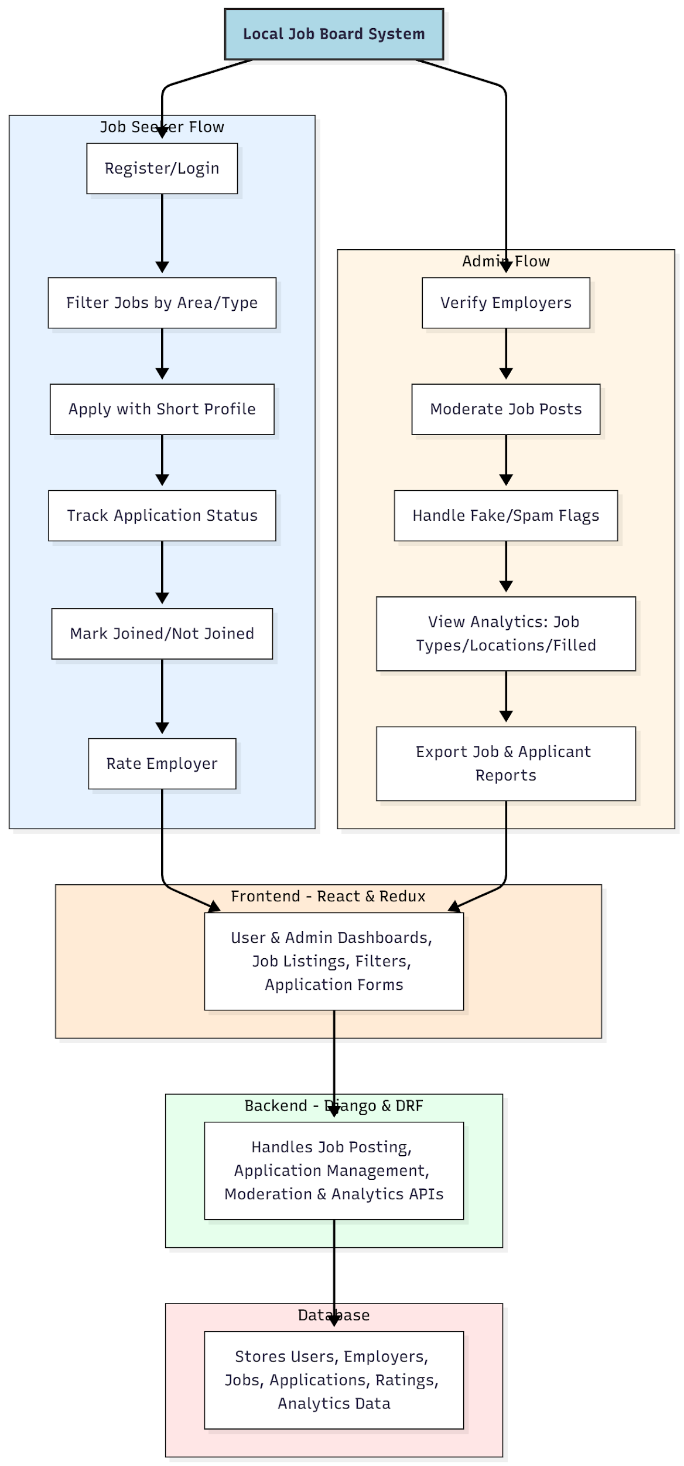

WORKING OF THE PROJECT:
Job seekers register on the portal and filter available jobs by location, type, or category. They can apply with a concise profile, track application status, mark whether they have joined or not, and rate employers. Administrators verify employer accounts, moderate job postings, and flag fake or spam entries. Analytical dashboards provide insights into job types, locations, and filled positions. Reports can be exported for record-keeping or trend analysis. The backend manages API requests, user and employer data, applications, ratings, and analytics computations. The frontend offers responsive dashboards, job listings, filters, and interactive forms for both job seekers and administrators..

SOFTWARE REQUIREMENT:
- Backend:
  - Python 3.x
  - Django
  - Django REST Framework
  - SQLite/PostgreSQL
- Frontend:
  - Node.js and npm
  - React.js
  - Axios
- Development Tools:
  - Visual Studio Code
  - Postman (for testing APIs)
  - Git/GitHub (for version control)
- Server/Deployment (Optional):
  - Gunicorn, Nginx, or Heroku/AWS for hosting

ADVANTAGES OF THE PROJECT:

• Streamlined job posting and application management for small businesses
• Efficient filtering and job discovery for seekers
• Transparent application tracking and employer ratings
• Prevents fake or spam listings
• Analytics dashboards for decision-making
• Exportable reports for monitoring and review
• Scalable and user-friendly system
• Reduces administrative workload and improves local employment efficiency

APPLICATIONS OF THE PROJECT:
• Local shops and retail businesses
• Tuition and coaching centers
• Small offices and startups
• Freelance or temporary job boards
• Community or neighborhood employment portals

REFERENCES:

- Django REST Framework Documentation — Django Software Foundation. Django Documentation. Available: https://docs.djangoproject.com/
- Django REST Framework. DRF Documentation. Available: https://www.django-rest-framework.org/
- React. React Official Documentation. Available: https://reactjs.org/docs/getting-started.html
- Redux. Redux Documentation. Available: https://redux.js.org/introduction/getting-started
- PostgreSQL Global Development Group. PostgreSQL Documentation. Available: https://www.postgresql.org/docs/
- MySQL. MySQL Reference Manual. Available: https://dev.mysql.com/doc/
- Git. Git Documentation. Available: https://git-scm.com/doc
- Node.js. Node.js Documentation. Available: https://nodejs.org/en/docs/
- Axios. Axios Documentation. Available: https://axios-http.com/docs/intro
- Socket.io Documentation – https://socket.io/docs/

